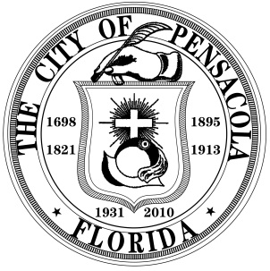
COUNCIL MEMORANDUM

Council Meeting Date: November 12, 2015

LEGISLATIVE ACTION ITEM

SPONSOR: Ashton J. Hayward, III, Mayor

SUBJECT: Ordinance Creating a Lobbyist Registration Program

RECOMMENDATION:

That City Council adopt the proposed ordinance creating Section 2-7-1 through 2-7-4 of the Code of the City of Pensacola to create a Lobbyist Registration Program.

AGENDA: __X__ Regular _____ Consent

Hearing Required: Public _____ Quasi-Judicial _____ No Hearing Required __X___

SUMMARY:

Over the past several years, Mayor Hayward and the City Council have worked together to ensure greater transparency in City government, including the adoption of a Code of Ethics, the publication of monthly financial reports, and an overhaul of the City’s public records function.

The proposed ordinance would require lobbyists to register with the City Clerk on an annual basis, to disclose any direct business associations with any City Council member or the Mayor, and to verbally disclose their status as a lobbyist and identify the principal on behalf of whom they are lobbying when addressing the City Council or other decision-making body. The ordinance would also prohibit lobbyists from knowingly making false statements when lobbying. Adopting such a program would ensure greater transparency and provide citizens, as well as the Mayor and City Council members, with more information throughout the decision-making process.

Many cities in Florida have established successful lobbyist registration programs, and the proposed ordinance was modeled after similar ordinances throughout the state, including those adopted by the cities of Tallahassee and West Palm Beach, as well as Broward County.

PRIOR ACTION:

None

FUNDING:

None

Council Memorandum
Subject: Ordinance Creating a Lobbyist Registration Program
Date: March 12, 2015
Page 2

FINANCIAL IMPACT:

None

STAFF CONTACT:
Richard Barker, Jr., CFO, Interim City Administrator
Tamara Fountain, Chief Operations Officer

ATTACHMENTS:

- Proposed Ordinance

PRESENTATION:
None

